Budget Rent A Car 
of British Columbia

UAT Guidelines for Issue Resolution

Version 1.00

Note: The information contained in this document is confidential and may not be disclosed to any parties outside of Budget Rent a Car of British Columbia without written consent by one of its officers.
Copyright (C) 1999 Budget Rent a Car of British Columbia
Table of Contents:
1. Introduction 1
2. PVCS Tracker 1
2.1. Entering New Issues 1
2.1.1. Title 2
2.1.2. Issue Description 2
2.1.3. User Priority 2
2.1.4. Author 3
2.1.5. Owner 3
2.1.6. Create Date 3
2.1.7. State 3
2.1.8. Detected in UAT Release 3
2.1.9. GIS Component 4
2.1.10. GIS Functional Area 4
2.2. Updating Existing Issues 4
2.3. Attaching Screenshots to an Issue 5
3. SnagIt! Windows Screen Capture Utility 6
3.1. Configuration 6
3.2. Making a Screen Shot 7
3.3. Saving a Screen Shot 7

Introduction
A number of tools have been introduced in the user acceptance test (UAT) environment to assist the testing staff in capturing information surrounding an issue. This document is intended to describe how these tools are to be used, as well as some guidelines for data entry.

PVCS Tracker
The PVCS Tracker software is used for tracking all issues surrounding the GIS project. It will be used by the testing staff when entering new issues, adding clarification to an existing issue, determining whether a particular issue has been addressed and whether the issue can be retired.

Entering New Issues
New issues are entered via PVCS Tracker’s “Submit Issue” screen.
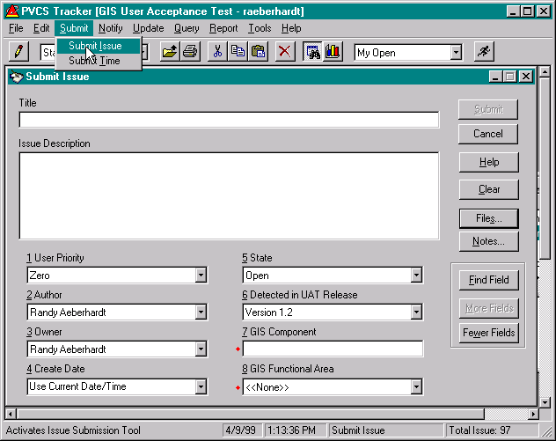
From Tracker’s Menu, select the “Submit Issue” entry to bring up the above form. This form is used to submit new UAT issues to Randy’s attention. Refer to the following sections on how to complete this form. The goal of entering issues is to provide sufficient information to the development team such that they are able to reproduce the issue and resolve it.
The following subsections provide additional information on the use of each of the fields on the “Submit Issue” screen.

Title
Enter a one line description of the issue. The description should provide enough information to provide a synopsis of the issue. A bad example of a title would be “Program does not work”. A better title is illustrated above.

Issue Description
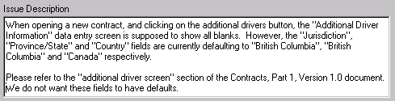
Enter a detailed description of the issue including references to the business design documents and, when possible, steps needed to reproduce the issue. The goal in describing the issue is to point out the issue in relation to the business design document. Also, enough information must be provided in the description to help the developer reproduce the issue. If you are unable to reproduce the issue, then thoroughly describe what it was you were doing at the time, the results you encountered and the fact that you are unable to reproduce the problem.
A description that does not meet the above criteria is insufficient.

User Priority
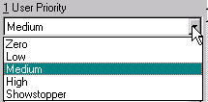
User Priority is a drop down box containing the following values:
“Zero” We can release the system without this issue addressed with no impact (usually used for cosmetic issues such as spelling mistakes).
“Low” We can release the system without this issue addressed with minimal impact (usually used if there is a simple, intuitive workaround to the problem and the issue occurs infrequently).
“Medium” We shouldn’t release the system without this issue addressed, but we could if we absolutely had to (usually used if there is a cumbersome workaround to the problem and the issue occurs frequently).
“High” We cannot release the system without this issue addressed, even if we wanted to (used if there is no workaround to the issue and the business risk is too great to release without the issue addressed).
“Showstopper” This is a “High” priority issue that is also blocking us from testing other critical areas of the system (used if user acceptance testing cannot continue in a particular area of the system unless the issue is addressed).
Please review the issue carefully and choose a user priority based on the above criteria.

Author
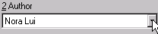
This field will default to the name of the PVCS Tracker user who last signed on to the PVCS system. This should always default to your name (unless you are using someone else’s PC). If the incorrect name is displayed, please log off PVCS Tracker and reenter the issue.

Owner
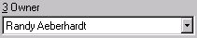
This field always defaults to “Randy Aeberhardt”. This field determines whose “in-tray” will display the issue once it has been entered into PVCS Tracker. Currently, all issues are routed through Randy, who will categorize it and forward it to development or return it to the Author for further clarification (if necessary).

Create Date
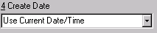
This field simply records the date and time when the issue is first entered into PVCS Tracker. Please do not update this field.

State
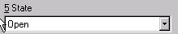
This field indicates the state of the issue. Only “Open” issues will be actively reviewed and addressed. This field defaults to “Open”, so do not change it if you wish your issue to be addressed.

Detected in UAT Release
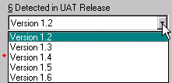
This field indicates the UAT Version number (shown as UAT Rel 1.2 on the initial GIS screen). This field defaults to the latest release number delivered into UAT by Sierra. Please ensure that this field matches the release in which the issue was detected.

GIS Component
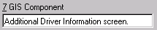
This field does not have any defaults. Please enter the name of the screen or report in this box. Use the name from the top of the GIS screen (e.g. “Contract Open/Check Out”) or the title bar of the pop-up box involved (e.g. “Contract Open Check Out Password). If a report is involved, please enter the title of the report in this field.
Always add the work “screen” or “report” to the end of this field to indicate whether the component involved is a screen or report.

GIS Functional Area
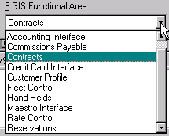
This field is used to associate the issue with a particular functional area of the GIS system. Please choose the appropriate value from the drop down menu.

Updating Existing Issues
This section to be fleshed out later.

Attaching Screenshots to an Issue
If you feel that a screen shot would add additional clarity to the issue, then please use the SnagIt! program to capture a screen shot and save it to the network (refer to section 3 for additional information). Once a screen shot has been saved to the network, it can be attached to an issue as follows:
Click on the “Files” button on the “Submit Issue” or “Update Issue” to display the following dialog box (if some files have already been attached to this issue, then their names will appear in the Files box):
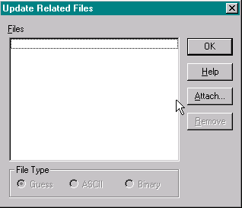
Click on the “Attach…” button above to tell Tracker where the screen shot is located:
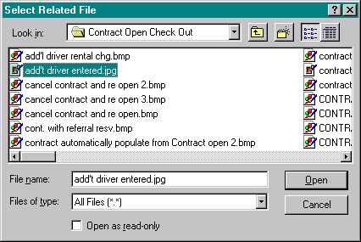
Finally, click on the name of the screen shot file you wish to attach to this issue and then click “Open”. When you are returned to the “Update Related Files” screen, you will now see the name of the file you attached. Click “OK” to finish.

SnagIt! Windows Screen Capture Utility
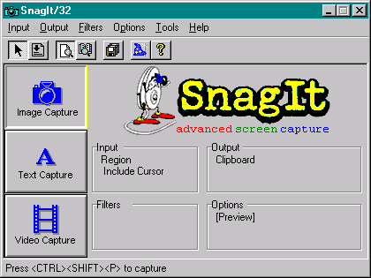
The SnagIt! windows screen capture utility is used to capture screen images and save them in a compressed (JPEG) file format. Once saved, these screen shots can be attached to any issue using PVCS Tracker (see section 2.3).

Configuration
Before using SnagIt!, you must ensure that the following configuration steps have been completed:
- From the “Input” menu, ensure that the “Window” and “Include Cursor” menu entries have a check mark next to them.
- From the “Output” menu, ensure that the “File” and “Preview Window” menu entries have a check mark next to them.
- Select the “Properties…” entry from the “Output” menu to display the following dialog box and ensure that the same options have been selected:
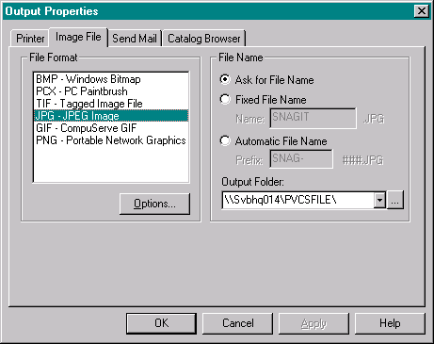

Making a Screen Shot
To make a screen shot, you must first run the SnagIt! program, either by double clicking on the desktop icon, or selecting the SnagIt! entry from your start menu. Once running, minimize the program so that it will not get in your way. Now, click on your GIS program to bring it to the front. Reproduce the situation you wish to capture (if you haven’t already done so) and then click the following keys together:
<Shift><Ctrl><P>
This will cause SnagIt! to display a red box around any area of the screen that can be captured. Move the mouse pointer around until the red box covers the portion of the screen you wish to capture. Now click the left mouse button and the SnagIt! preview window will appear. Verify that the screen shot is correct and then click on the green arrow (illustrated below) to direct SnagIt! to save the file.
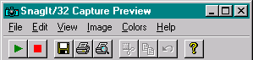

Saving a Screen Shot
When saving a screen shot using SnagIt!, please ensure that all files are saved to a consistent location on the network such that other users may find and access them. To this end, a network share “\\SVBHQ014\PVCSFILES” has been created where all screen shots are to be saved. A number of subdirectories have been created in this share. Please choose the directory that most matches the area of the system associated with the issue you are capturing.
When saving the screen shot (as defined in the previous section), the following dialog is displayed:
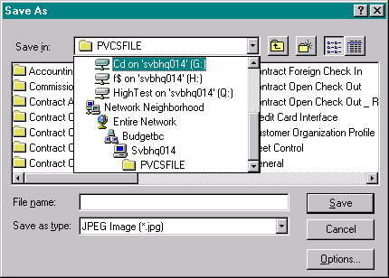
Please ensure that you navigate the network (and not a mapped drive) when saving the file. Give the screen shot a descriptive name (maybe use the same name as the issue title) and save the file as a JPEG image.

